Theme Development

05 Theme dev

Place holder Screenshot

Tony Evans

**Add a Widget**

**Sidebar**

See next page for screenshots of what your page should look like

In this folder you can see the following:

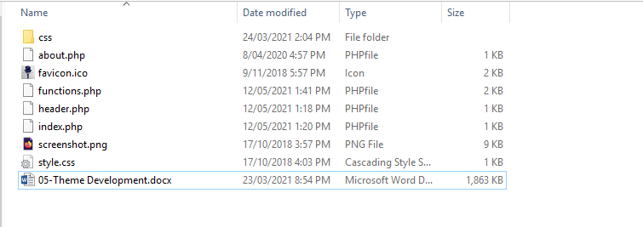

The following Tutorial explains how to add a widget to your theme.

# Widgets or Sidebars

A widget area is also known as a sidebar. To start adding a widget to your site you will need to edit the “functions.php”.

Open the “functions.php” file in notepad++.

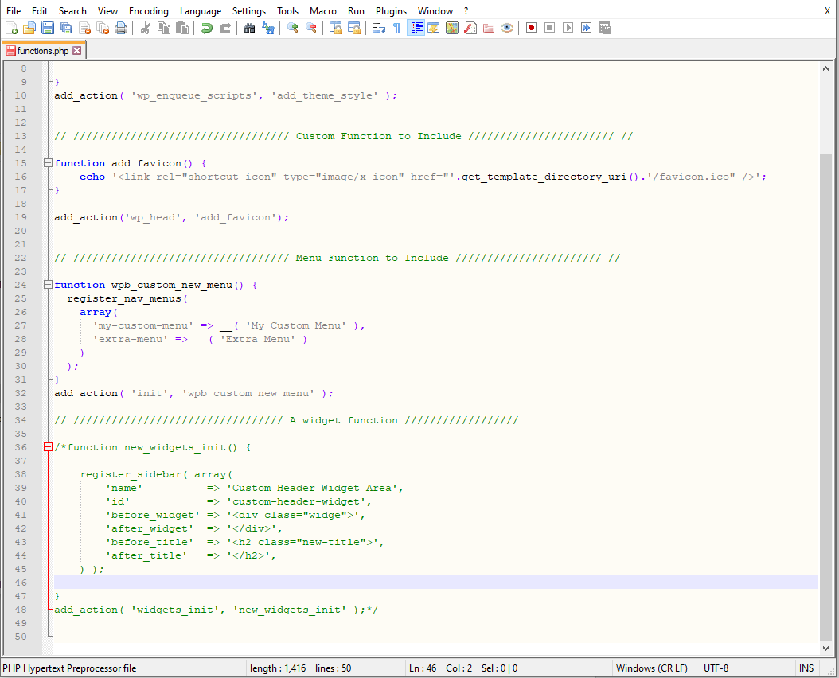

Scroll down until you see the commented code under the “A widget function” comment. This code is available on WodrPress.org – Theme Handbook - <https://developer.wordpress.org/themes/functionality/sidebars/>

Open your WordPress installation to have a look at the available options.

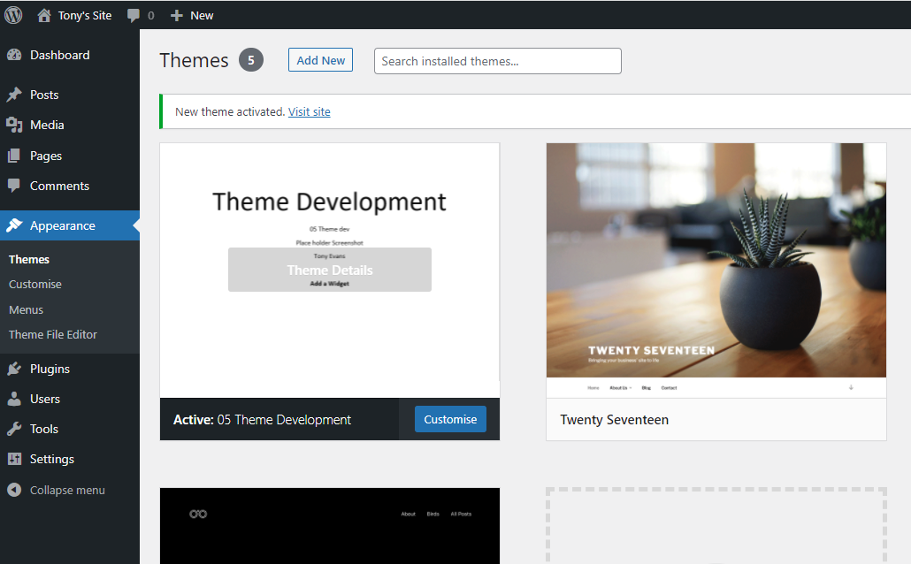

Notice that there is no “widgets” appearing under the “Appearance” menu. This is because the code is commented out and is not registered. If you do not want your users to access widgets or sidebars, then do not register them.

To register the widget area, uncomment the code in the “fucntions.php” file.

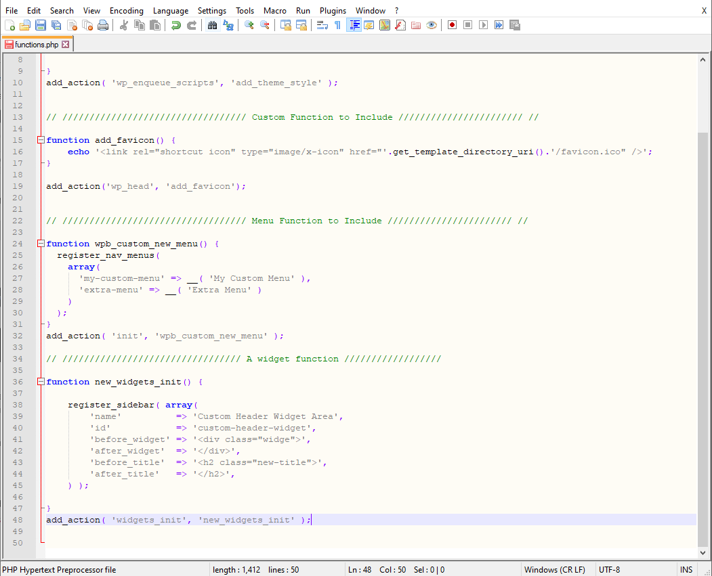

Now that the code is uncommented have a look at WordPress admin area.

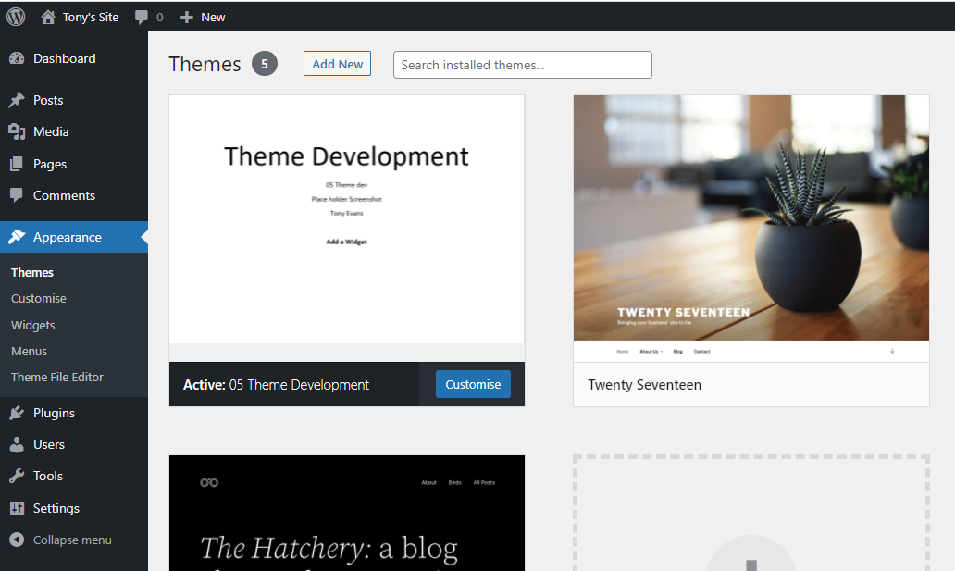

Click on the Widgets menu item and have a look at the widget area available.

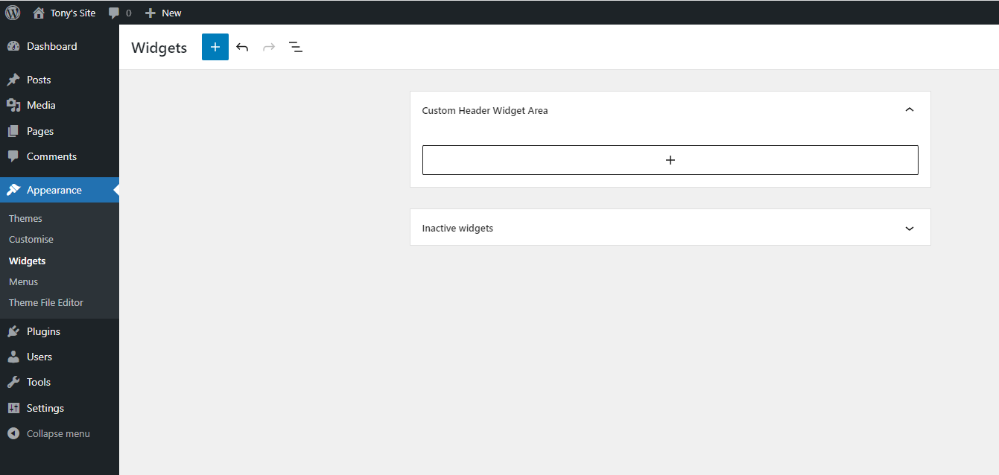

Notice the name of the widget area “Custom Header Widget Area”. Look at the code in the “fucntions.php” file



The next step we need to have a look at is where is the widget area appearing on the front page.

Open up the front page view to see what is happening.

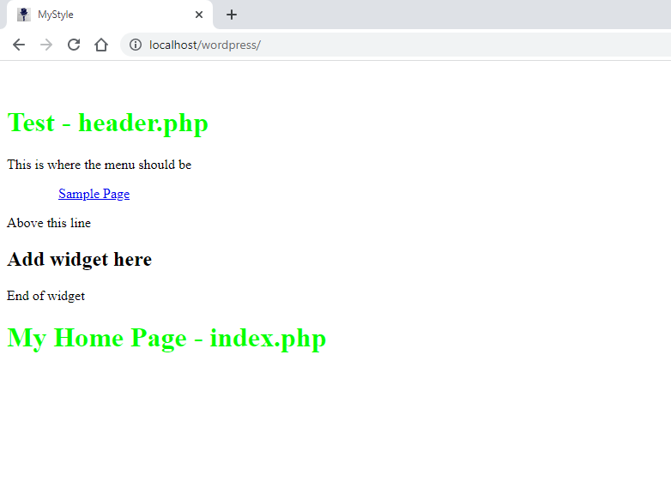

You will notice that the area above shows a heading to demonstrate where the widget will go.

Open the “header.php” file to have a look at the code.

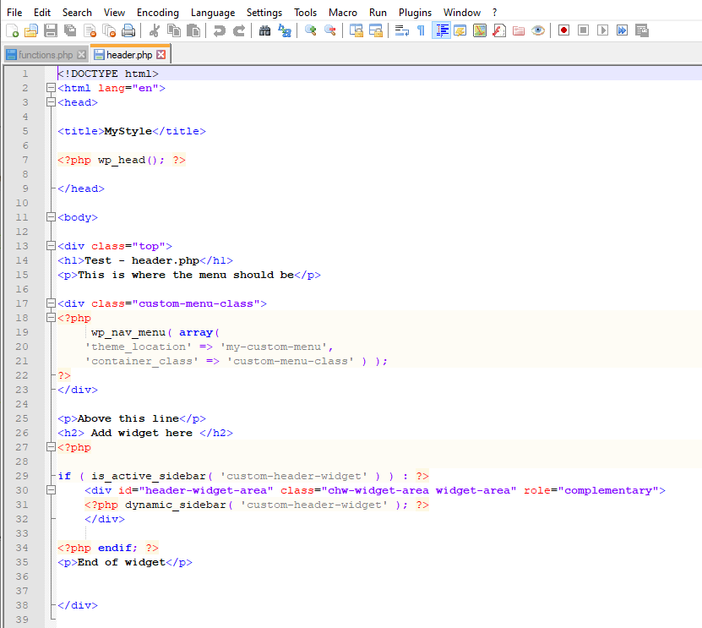

You can see the this showing where the widget we want to add is located. The code underneath the heading is php code to show our new widget. It does not show anything at the moment because there is no widget feature added to the area. For simple demonstration a calendar can be added. Try other features to see what happens.

Go back to the admin area and click on the widgets menu item.

Click the + sign to add a feature.

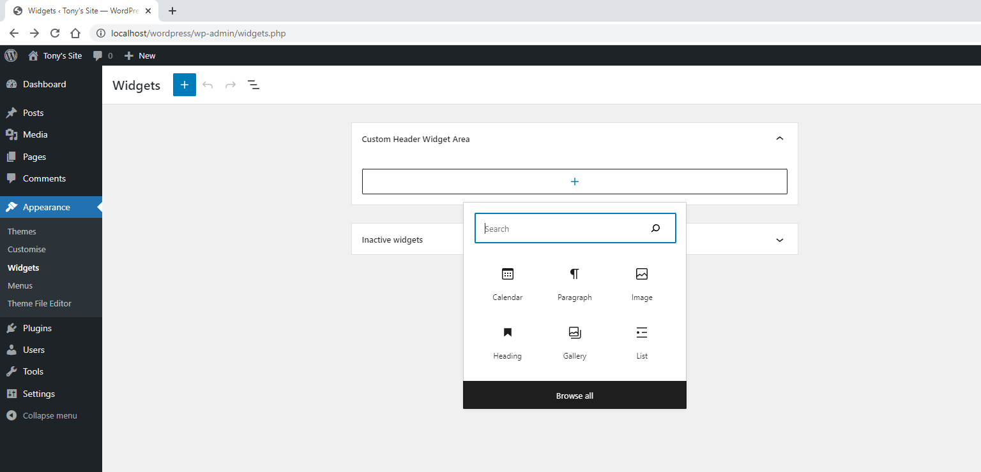

Click calendar.

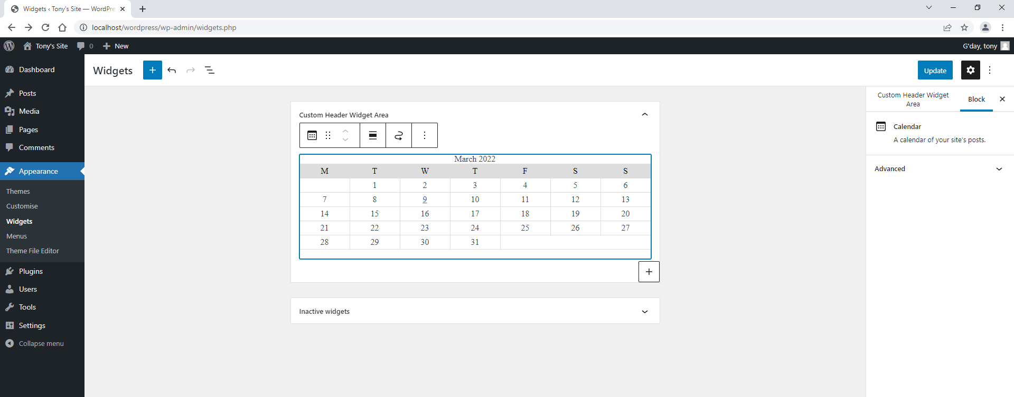

Click the “update” button.

Return to the front page and view the widget.

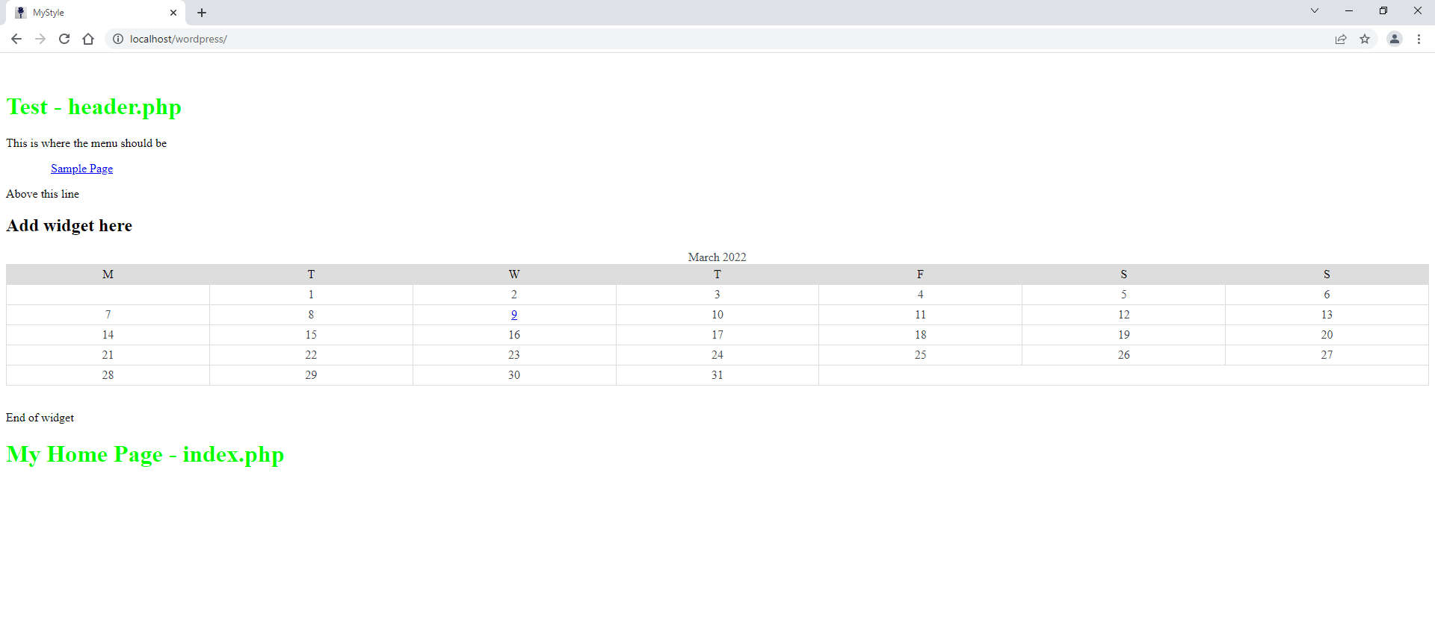

You can style this area to show on either side of the page or as it is across the whole page.

Try adding another feature to see how it works.

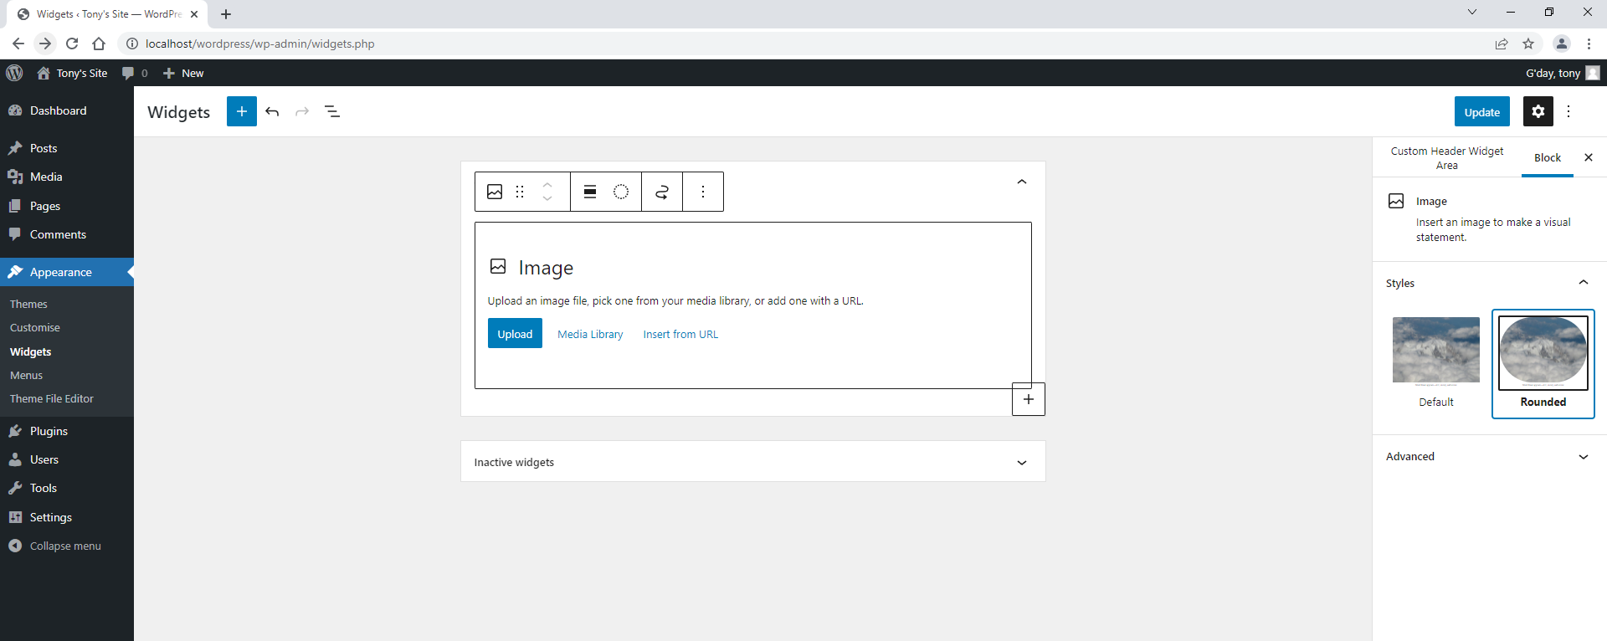

This one is an image. Remember that by adding this you are enabling the client to change what they want on the site.

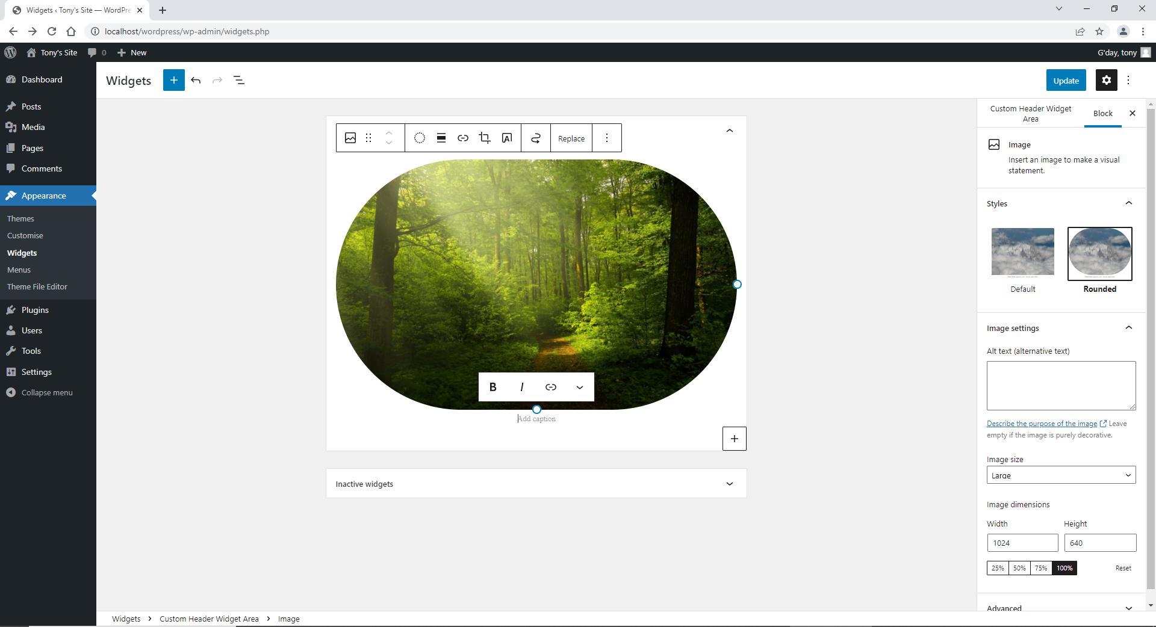

Click the “update” and then view the page.

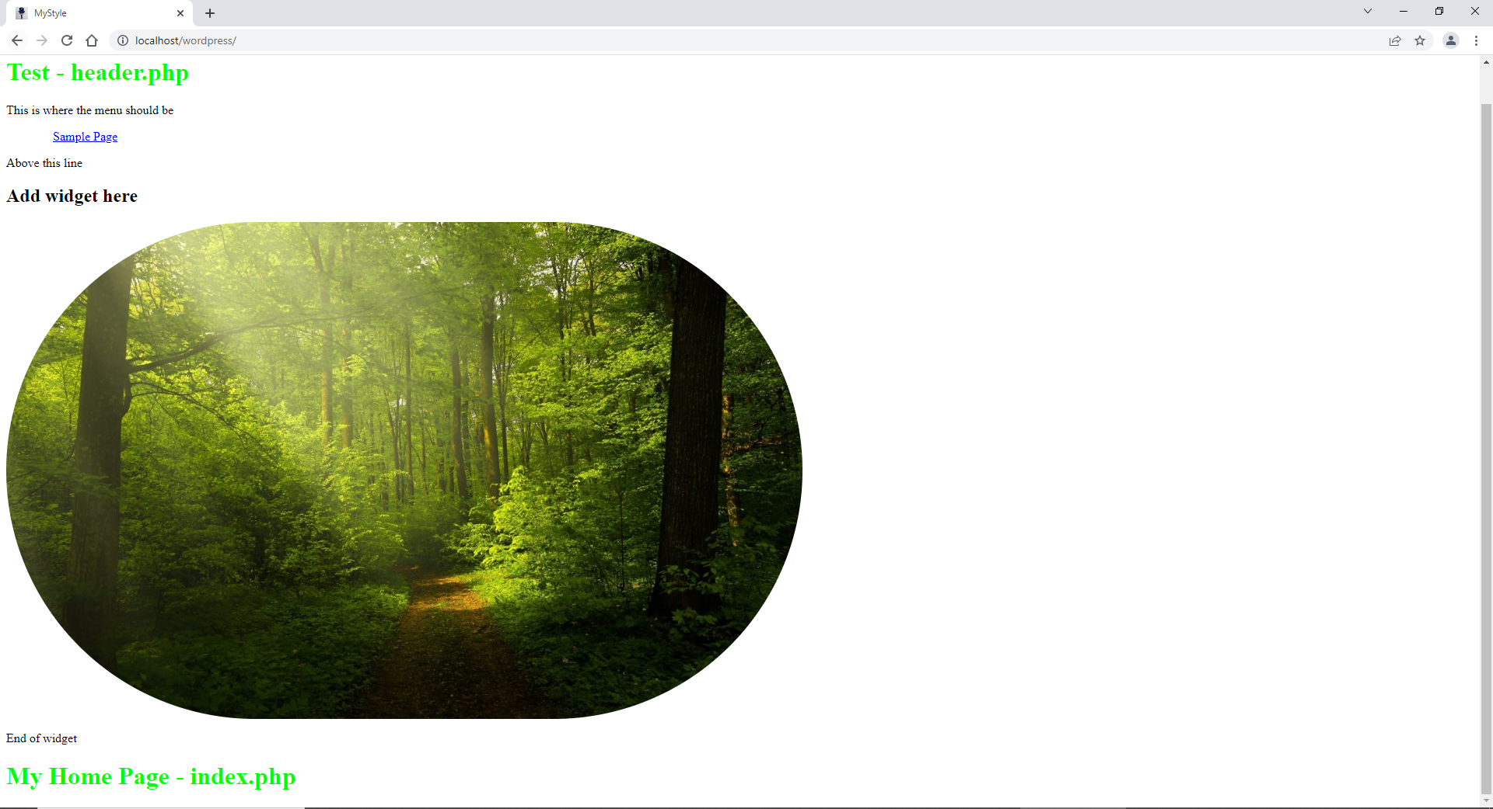

Looks like I’ve created a very ugly page so it needs a lot more work to style and look professional.

You can also have a look at the “index.php” file which also has the widget area, to show that you can place in different areas on your page.

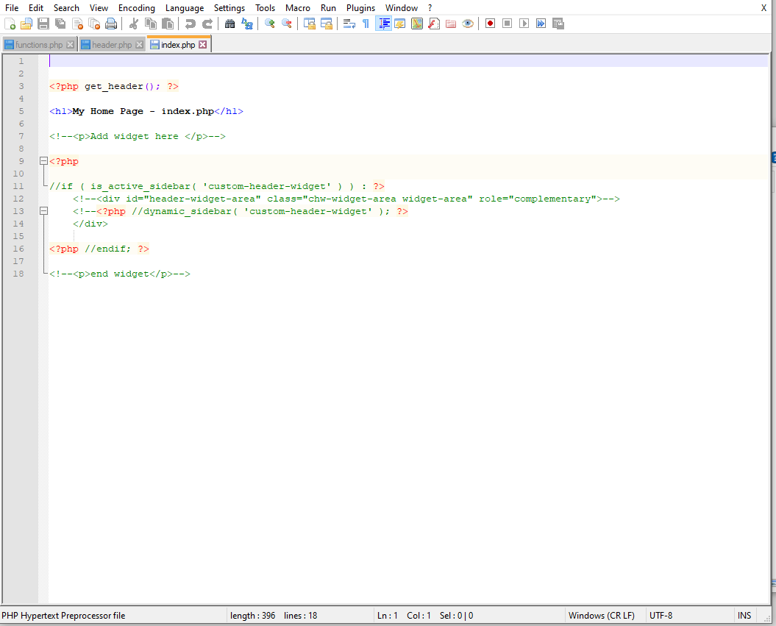

Uncomment and you will see the widget feature pop up on the page.

We can start to work on the next steps. See 06-Theme Development